**LAB – 10**

18MIS7250

AMIT KUMAR SAHU

**NAT – Network Address Translation**

Network Address Translation (NAT) is the process where a network device, usually a firewall, assigns a public address to a computer (or group of computers) inside a private network. The main use of NAT is to limit the number of public IP addresses an organization or company must use, for both economy and security purposes.

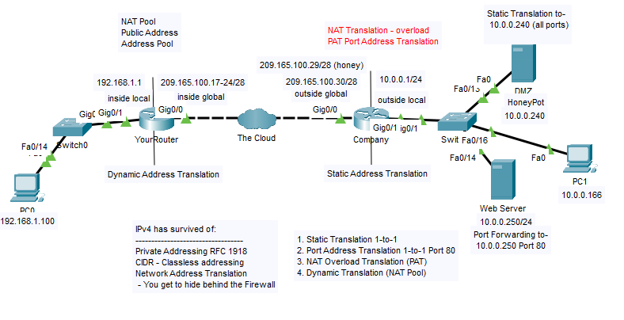

**Configuring a static NAT translation from the address 209.165.100.29 to 10.0.0.240**

company>en

company#conf t

Enter configuration commands, one per line. End with CNTL/Z.

company(config)#int g0/0

company(config-if)#ip nat out

company(config-if)#int g0/1

company(config-if)#ip nat inside

company(config-if)#ip nat inside source static 10.0.0.240 209.165.100.29

company(config)#

**verifying it works by opening a web browser on PC0 and going to 209.165.100.29**

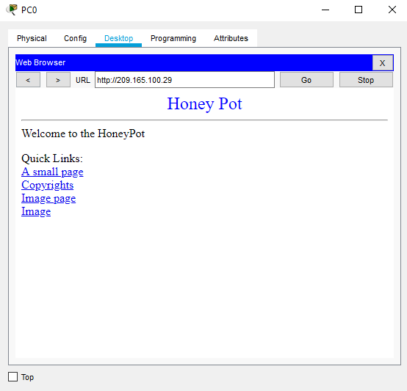

Configuring port forwarding, from 209.165.100.30 on port 80 to 10.0.0.250 on port 80

company(config)#int g0/0

company(config-if)#int nat outside

company(config-if)#int g0/1

company(config-if)#ip nat inside

company(config-if)#exit

company(config)#ip nat inside source static tcp 10.0.0.250 80 209.165.100.30 80

company(config)#

**verifying it works by opening a web browser on PC0 and going to 209.165.100.30**

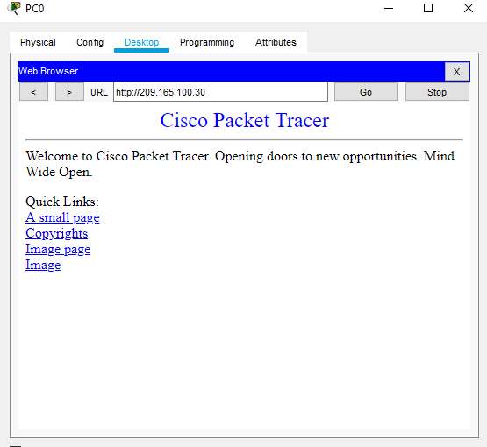

**Configuring a NAT overload translation from the 10.0.0.0/24 network to interface G0/0**

company(config)#access-list 10 permit 10.0.0.0 0.0.0.255

company(config)#ip nat inside source ?

list Specify access list describing local addresses

static Specify static local->global mapping

company(config)#ip nat inside source

% Incomplete command.

company(config)#ip nat inside source 10 ?

% Unrecognized command

company(config)#ip nat inside source list 10 ?

interface Specify interface for global address

pool Name pool of global addresses

company(config)#ip nat inside source list 10 interface g0/0 overload

company(config)#exit

company#

%SYS-5-CONFIG_I: Configured from console by console

company#show ip nat translation

Pro Inside global Inside local Outside local Outside global

icmp 209.165.100.30:1 10.0.0.100:1 192.168.1.100:1 192.168.1.100:1

icmp 209.165.100.30:2 10.0.0.100:2 192.168.1.100:2 192.168.1.100:2

icmp 209.165.100.30:3 10.0.0.100:3 192.168.1.100:3 192.168.1.100:3

icmp 209.165.100.30:4 10.0.0.100:4 192.168.1.100:4 192.168.1.100:4

--- 209.165.100.29 10.0.0.240 --- ---

tcp 209.165.100.29:80 10.0.0.240:80 192.168.1.100:1025 192.168.1.100:1025

tcp 209.165.100.29:80 10.0.0.240:80 192.168.1.100:1026 192.168.1.100:1026

tcp 209.165.100.30:80 10.0.0.250:80 --- ---

tcp 209.165.100.30:80 10.0.0.250:80 192.168.1.100:1027 192.168.1.100:1027

**verifying it works by successfully pinging from PC1 to PC0. Change the IP address of PC1 to 10.0.0.166 and test again. From the command line issue the command *show ip nat translations* to verify the address and port translations**

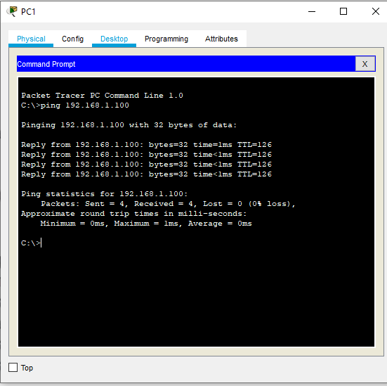

**Changing ip address of PC 1 to 10.0.0.166 and checking if it’s working**

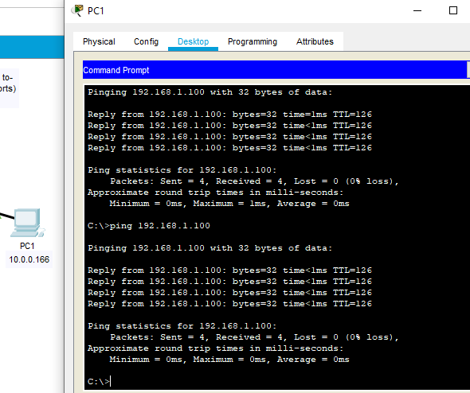

company#show ip nat translation

Pro Inside global Inside local Outside local Outside global

icmp 209.165.100.30:5 10.0.0.166:5 192.168.1.100:5 192.168.1.100:5

icmp 209.165.100.30:6 10.0.0.166:6 192.168.1.100:6 192.168.1.100:6

icmp 209.165.100.30:7 10.0.0.166:7 192.168.1.100:7 192.168.1.100:7

icmp 209.165.100.30:8 10.0.0.166:8 192.168.1.100:8 192.168.1.100:8

--- 209.165.100.29 10.0.0.240 --- ---

tcp 209.165.100.29:80 10.0.0.240:80 192.168.1.100:1025 192.168.1.100:1025

tcp 209.165.100.29:80 10.0.0.240:80 192.168.1.100:1026 192.168.1.100:1026

tcp 209.165.100.30:80 10.0.0.250:80 --- ---

tcp 209.165.100.30:80 10.0.0.250:80 192.168.1.100:1027 192.168.1.100:1027

**Configure dynamic NAT translation using a NAT Pool of addresses 209.165.100.17 to 209.165.100.24, to the 192.168.1.0/24 network with overload**

YourRouter#conf t

Enter configuration commands, one per line. End with CNTL/Z.

YourRouter(config)#int g0/0

YourRouter(config-if)#ip nat outside

YourRouter(config-if)#int g0/1

YourRouter(config-if)#ip nat inside

YourRouter(config-if)#

YourRouter(config-if)#access-list 1 ppermit 192.168.1.0 0.0.0.255

^

% Invalid input detected at '^' marker.

YourRouter(config-if)#access-list 1 permit 192.168.1.0 0.0.0.255

YourRouter(config)#

YourRouter(config)#ip nat MYPOOL ?

% Unrecognized command

YourRouter(config)#ip nat pool ?

WORD Pool name

YourRouter(config)#ip nat pool MYPOOL ?

A.B.C.D Start IP address

YourRouter(config)#ip nat pool MYPOOL 209.165.100.17 209.165.100.24 ?

netmask Specify the network mask

YourRouter(config)#ip nat pool MYPOOL 209.165.100.17 209.165.100.24 netmask?

netmask

YourRouter(config)#ip nat pool MYPOOL 209.165.100.17 209.165.100.24 netmask 255.255.255.240

YourRouter(config)#

YourRouter(config)#

YourRouter(config)#ip nat inside source list 1 ?

interface Specify interface for global address

pool Name pool of global addresses

YourRouter(config)#ip nat inside source list 1 pool MYPOOL ?

overload Overload an address translation

<cr>

YourRouter(config)#ip nat inside source list 1 pool MYPOOL overload

YourRouter(config)#

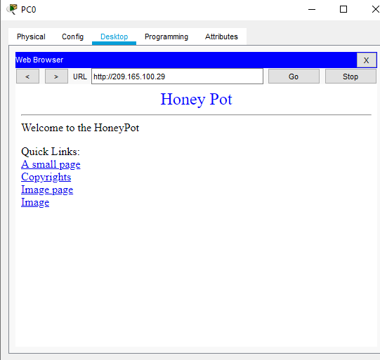

YourRouter#

%SYS-5-CONFIG_I: Configured from console by console

YourRouter#show ip nat translations

Pro Inside global Inside local Outside local Outside global

tcp 209.165.100.17:1028192.168.1.100:1028 209.165.100.29:80 209.165.100.29:80

YourRouter#

**verifying it works by successfully pinging from PC0, to 209.165.100.29 and from the command line issue the command *show ip nat translations***

